DY049143
  - Parts of the Rollator
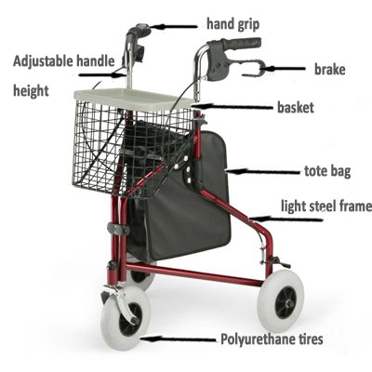
  - Methods of Usage and Operation
Overview: A Rollator is a walker with four wheels. This type of walker usually has a hard, plastic or padded seat between the Rollator frame and a basket on the front of the walker or under the seat. A Rollator is used by people who need support while walking due to unsteadiness, disability or recovery from surgery.
Step 1
Lock the brakes on the Rollator by pushing the brake handles down. You will hear a snap as the brakes lock into position.
Step 2
Place both feet side-by-side in the middle of the Rollator frame.
Step 3
Release the brakes by pulling the brake handles up.
Step 4
Grasp the hand grips on either side of the Rollator.
Step 5
Push the Rollator forward to a comfortable distance. Your toes should be even with the back wheels of the Rollator.
Step 6
Step forward toward the inside of the Rollator frame with your weaker leg.
Step 7
Step forward with your stronger leg while supporting yourself with the hand grips. Both feet should be side-by-side between the wheels of the Rollator.
Step 8
Continue walking by repeating Steps 5 through 7.

  - Tips and Warnings
(1). Keep a part of your body, like your toes, within the Rollator frame at all times. When standing from a sitting position, push up from the seat instead of pulling up on the Rollator handles. Apply the brake before sitting and make sure the brake is applied before standing to use the Rollator. When turning, take small steps and keep your hips parallel to the front bar of the Rollator. Avoid twisting your body away from the Rollator. Engage the brakes before sitting on the Rollator seat.

(2). Don't sit on the Rollator seat and use this device as a temporary wheelchair unless your particular Rollator is approved for this use. The Rollator can tip over causing injury. Ensure all four wheels of the Rollator are on level ground before walking. Don't hunch forward over the Rollator. A Rollator is not recommended for use on an escalator or stairs. Don't place heavy objects in the basket because this can cause the Rollator to tip over. Always follow the recommended weight limit of your particular brand of rollator.

